Test Case: tc002_SPX_Dev5_Crear_Requisicion_Spot_Tipo_Cobro_Project
Step 1 - Enter username and password and click to button Enter: Credentials Entered
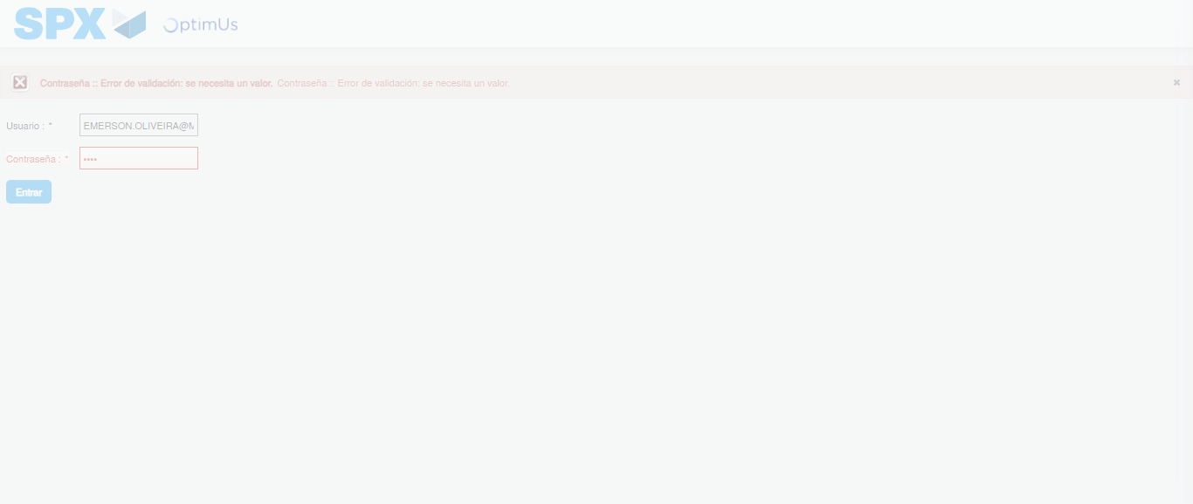Image file-name: QC_Testing-tc002_SPX_Dev5_Crear_Requisicion_Spot_Tipo_Cobro_Project-1784233101482

Step 2 - Select to UEN and Access to Spot Buy Requisitions : UEN Correctly selected and Correct access
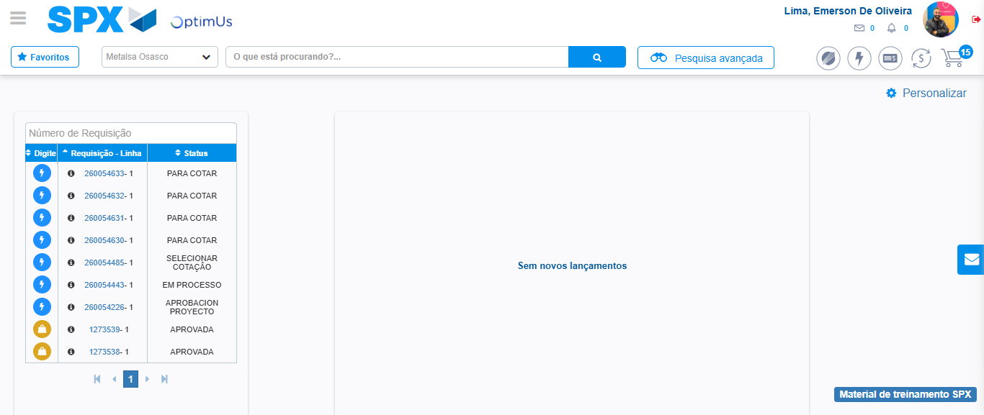Image file-name: QC_Testing-tc002_SPX_Dev5_Crear_Requisicion_Spot_Tipo_Cobro_Project-1784233126852

Image file-name: QC_Testing-tc002_SPX_Dev5_Crear_Requisicion_Spot_Tipo_Cobro_Project-1784233129347

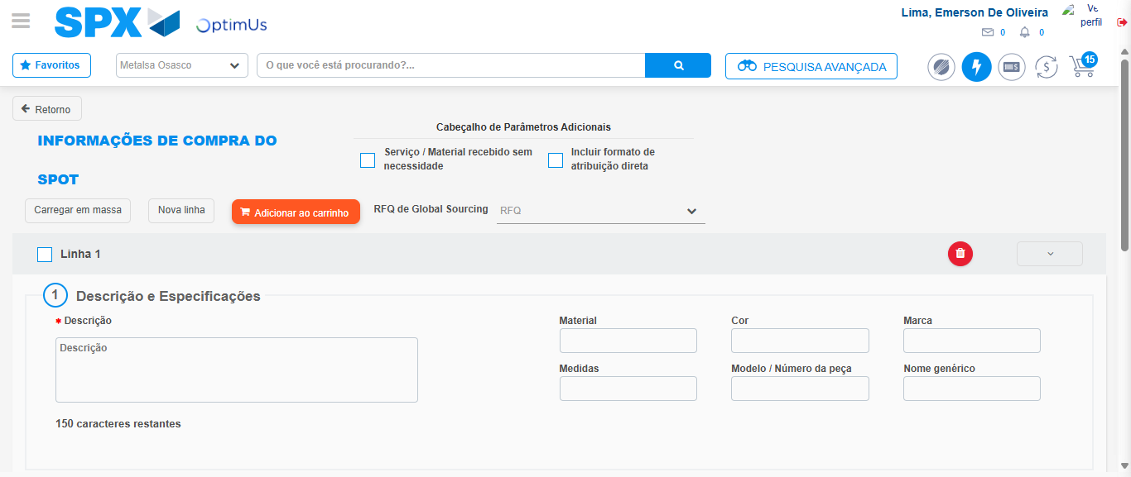Image file-name: QC_Testing-tc002_SPX_Dev5_Crear_Requisicion_Spot_Tipo_Cobro_Project-1784233148903

Step 3 - Data Capture Spot Buy Requisition: Data captured correctly
Image file-name: QC_Testing-tc002_SPX_Dev5_Crear_Requisicion_Spot_Tipo_Cobro_Project-1784233149177

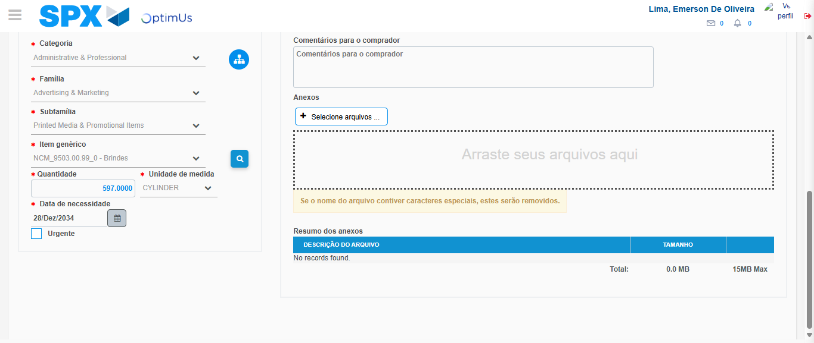Image file-name: QC_Testing-tc002_SPX_Dev5_Crear_Requisicion_Spot_Tipo_Cobro_Project-1784233162433

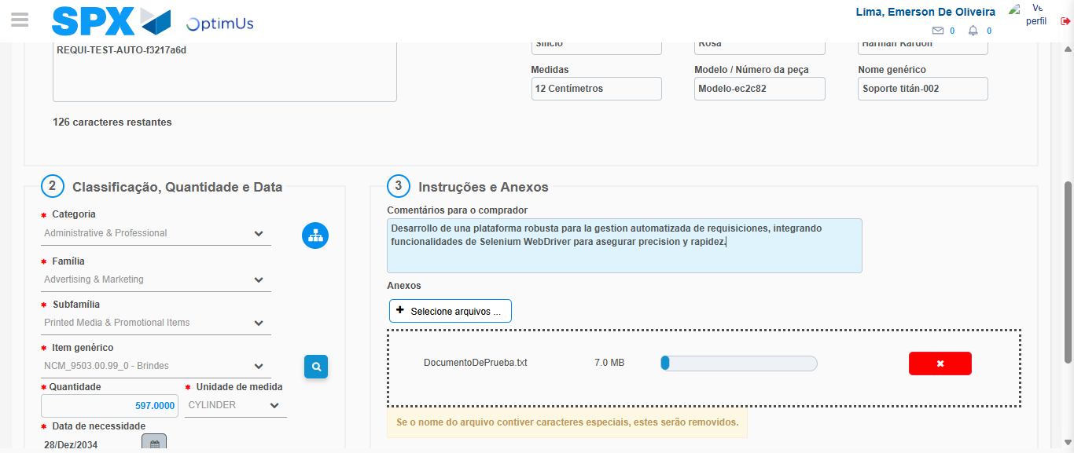Image file-name: QC_Testing-tc002_SPX_Dev5_Crear_Requisicion_Spot_Tipo_Cobro_Project-1784233163378

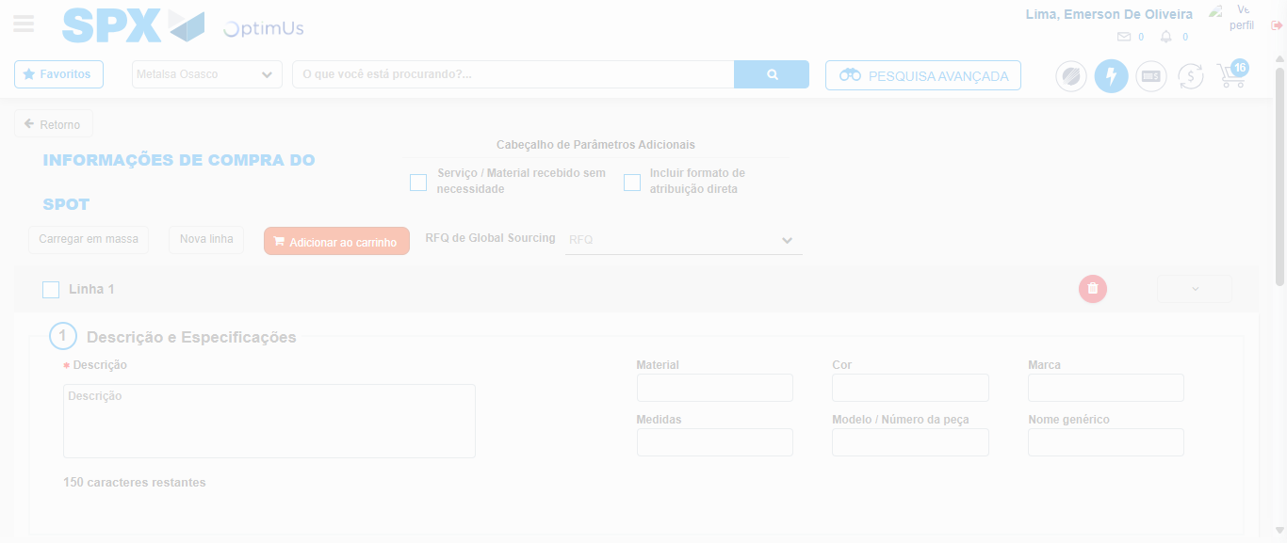Image file-name: QC_Testing-tc002_SPX_Dev5_Crear_Requisicion_Spot_Tipo_Cobro_Project-1784233168593

Step 7 - Return to Main Page SPX : Return to Main Page SPX
Image file-name: QC_Testing-tc002_SPX_Dev5_Crear_Requisicion_Spot_Tipo_Cobro_Project-1784233126852

Image file-name: QC_Testing-tc002_SPX_Dev5_Crear_Requisicion_Spot_Tipo_Cobro_Project-1784233129347

Image file-name: QC_Testing-tc002_SPX_Dev5_Crear_Requisicion_Spot_Tipo_Cobro_Project-1784233148903

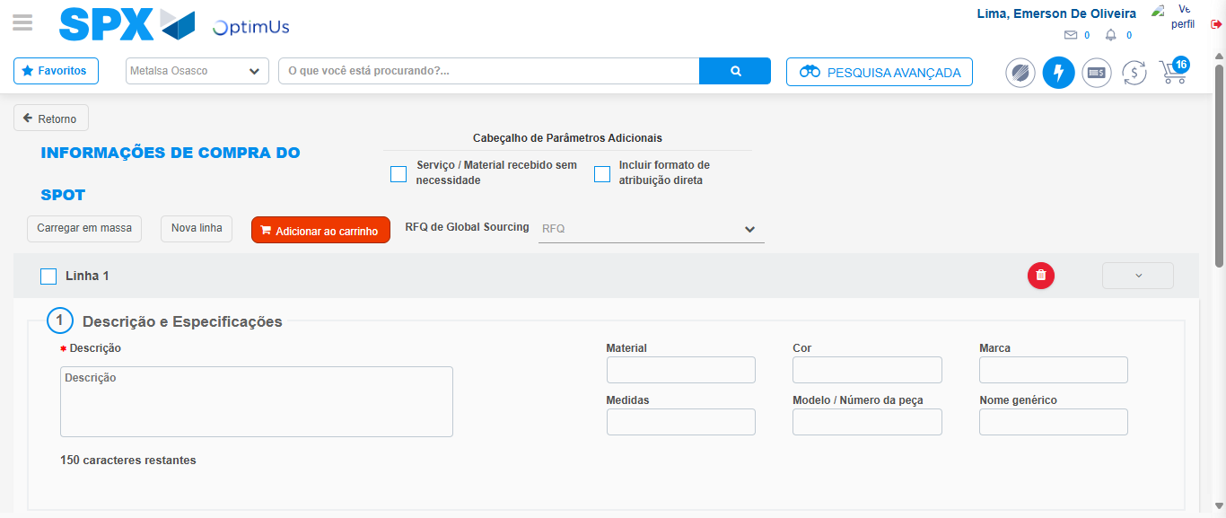Image file-name: QC_Testing-tc002_SPX_Dev5_Crear_Requisicion_Spot_Tipo_Cobro_Project-1784233170915

Image file-name: QC_Testing-tc002_SPX_Dev5_Crear_Requisicion_Spot_Tipo_Cobro_Project-1784233171118

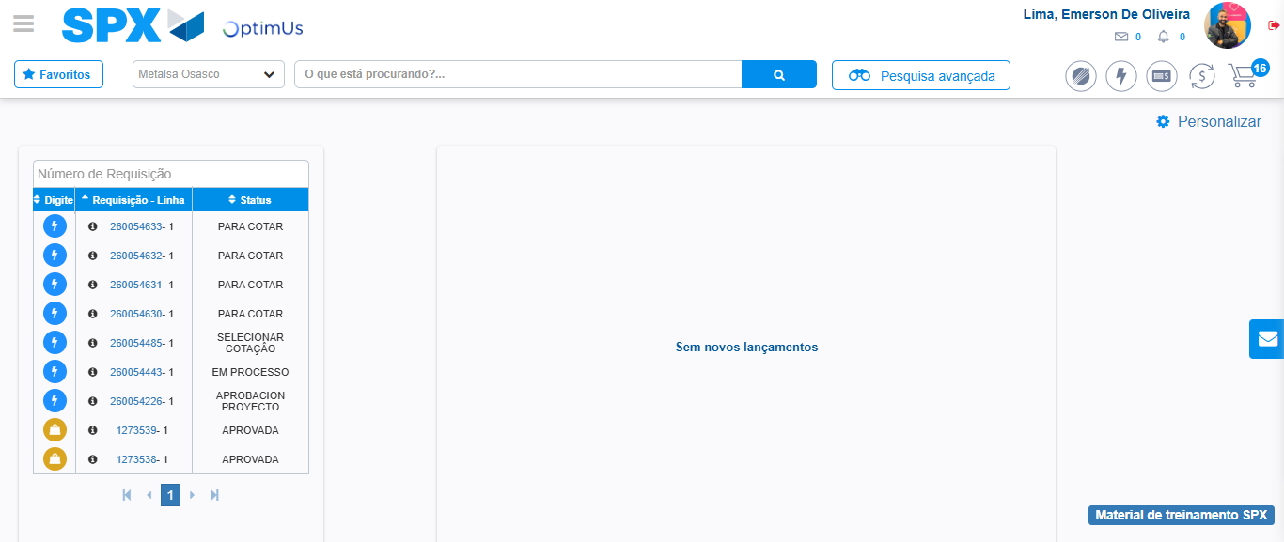Image file-name: QC_Testing-tc002_SPX_Dev5_Crear_Requisicion_Spot_Tipo_Cobro_Project-1784233192196

Step 8 - Log Out : Log Out SPX
Image file-name: QC_Testing-tc002_SPX_Dev5_Crear_Requisicion_Spot_Tipo_Cobro_Project-1784233192388

